A Low-Cost IoT-Based Smart Toilet Sanitation Monitoring System Using a Cleanliness Index
Problem Statement
Public toilets in places such as educational institutions, bus terminals, railway stations, hospitals, and shopping complexes are typically maintained through fixed cleaning schedules or manual inspections. This approach often fails to reflect the actual sanitation condition of the facility, resulting in delayed cleaning, unpleasant odor , overflowing waste bins, and unhygienic environments. Existing monitoring methods are labor intensive, inconsistent, and unable to provide real-time information to maintenance staff. Furthermore, many automated sanitation systems proposed in previous studies rely on multiple sensors and expensive infrastructure, making them difficult to deploy on a large scale. Therefore, there is a need for a low-cost, real-time sanitation monitoring system that can continuously assess toilet cleanliness, generate timely maintenance alerts, and support efficient cleaning operations using minimal hardware resources while maintaining effective monitoring performance.

Abstract
Public toilets often become unhygienic due to high usage and delayed cleaning. Regular manual inspection is time-consuming and may not always reflect the actual condition of the toilet. This project proposes a low-cost Smart Toilet Sanitation Monitoring System using an ESP32, air quality sensor, PIR sensor, and ultrasonic sensor. The system monitors odor levels, user activity, and dustbin status in real time. Based on these parameters, a cleanliness score is calculated and displayed on a dashboard. When the cleanliness level falls below a set threshold, an alert is sent to the cleaning staff. The proposed system helps improve hygiene, reduce manual monitoring, and ensure timely maintenance at a low cost.

Objectives
- To develop a low-cost smart toilet sanitation monitoring system using IoT technology.
- To monitor toilet hygiene conditions by measuring air quality, user activity, and dustbin fill level.
- To calculate a cleanliness score based on the collected sensor data.
- To provide real-time monitoring through a dashboard interface.
- To generate alerts when the toilet requires cleaning or maintenance.
- To reduce manual inspection efforts and improve sanitation management in public facilities.
- To ensure timely cleaning and maintain a hygienic environment for users.

Block Diagram

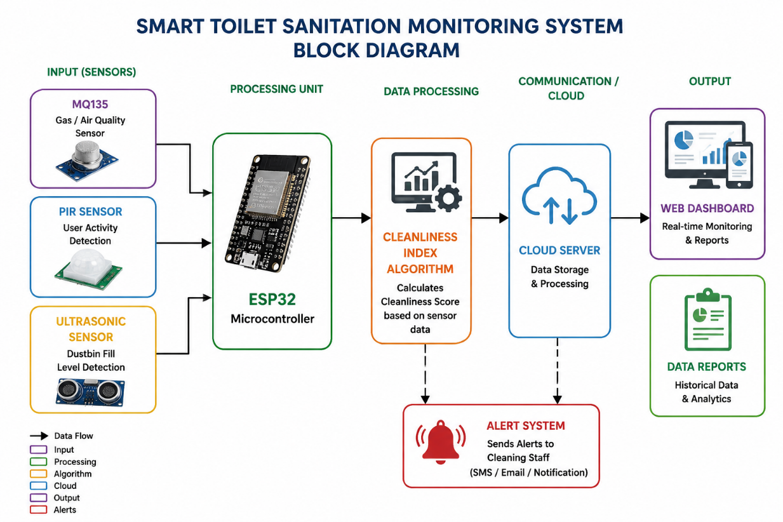

1. MQ135 Air Quality Sensor
- Monitors air quality and odor levels.
- Detects gases such as ammonia, smoke, and other pollutants.
- Used to assess the hygienic condition of the toilet environment.
2. PIR (Passive Infrared) Sensor
- Detects human presence and movement.
- Used to estimate toilet usage frequency and occupancy patterns.
3. HC-SR04 Ultrasonic Sensor
- Measures the distance between the sensor and waste level in the dustbin.
- Used to determine dustbin fill status and prevent overflow.

Flow Chart :

START
│
Initialize System
│
Collect Sensor Data (MQ135, PIR, Ultrasonic)
│
Process Sensor Values
│
Compute Cleanliness Index
│
Compare with Threshold
│
├── Clean → Update Dashboard
│
└── Dirty → Generate Alert
│
Notify Cleaner
│
Store Data
│
Repeat Monitoring

Step 1: Convert Sensor Values to Scores (0–100)
Air Quality Score (AQ)
Based on MQ135:
Good Air Quality = 100
Moderate Air Quality = 70
Poor Air Quality = 40
Very Poor = 10
User Activity Score (UA)
0–20 users = 100
21–50 users = 80
51–100 users = 60
101–150 users = 40
>150 users = 20
Dustbin Score (DB)
0–25% Full = 100
26–50% Full = 75
51–75% Full = 50
76–90% Full = 25
>90% Full = 10

Step 2: Cleanliness Index Formula
$CI=0.5(AQ)+0.2(UA)+0.3(DB)$
Where:
- CI = Cleanliness Index
- AQ = Air Quality Score
- UA = User Activity Score
- DB = Dustbin Score

Alert Condition
IF CI < 60
-> Send Cleaning Alert
IF CI < 40
-> Send High Priority Alert

Difference between existing idea and proposed idea

Feature | Existing Systems | Proposed System
Number of Sensors | 5–8 sensors | Only 3 sensors
Hardware Cost | ₹3000–₹8000 | Less than ₹1000
Cleanliness Index | Rarely available | Proposed
Low-Cost Deployment | Limited | Primary objective
Suitable for Rural/Public Facilities | Moderate | High
Maintenance Cost | Higher | Lower
Complexity | High | Simple and scalable

Existing Systems
- Focus on adding multiple sensors.
- Higher installation and maintenance costs.
- Display individual sensor readings.
Proposed System
- Uses only 3 low-cost sensors.
- Calculates a single Cleanliness Index (CI).
- Provides automatic cleaning alerts.
- Designed for affordable large-scale deployment.

Results and Discussion
The proposed Smart Toilet Sanitation Monitoring System was successfully developed and tested using an ESP32, MQ135 sensor, PIR sensor, and ultrasonic sensor. The system continuously monitored air quality, user activity, and dustbin fill level in real time. A Cleanliness Index was calculated based on the sensor readings and displayed on a monitoring dashboard.
During testing, the system successfully identified different sanitation conditions and generated alerts whenever the Cleanliness Index fell below the predefined threshold value. The dashboard provided real-time visualization of toilet status, enabling timely maintenance decisions.
The use of only three low-cost sensors reduced the overall system cost while maintaining effective sanitation monitoring. Experimental results showed that the proposed system can provide a practical and economical solution for monitoring public toilet cleanliness and supporting timely cleaning operations.

Sample Result Table

Scenario | AQ Score | UA Score | DB Score | CI | Status
Clean Toilet | 90 | 90 | 95 | 91.5 | Clean
Moderate Usage | 70 | 70 | 75 | 72.5 | Moderate
High Usage | 50 | 40 | 60 | 51 | Needs Cleaning
Poor Condition | 20 | 20 | 30 | 23 | Critical

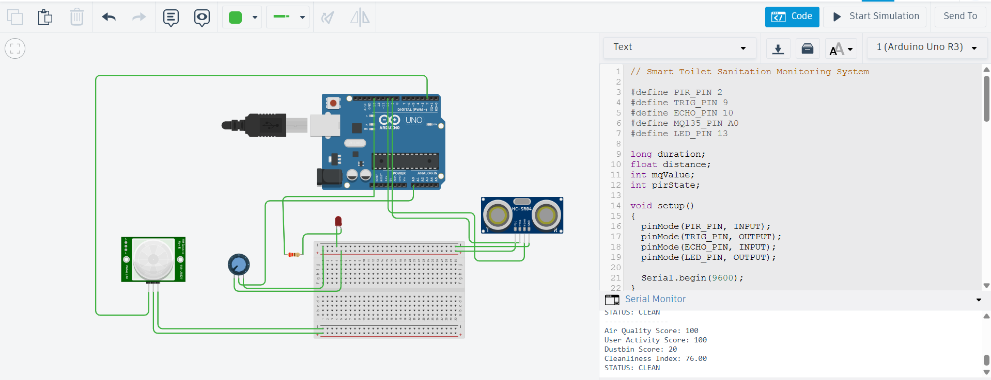

Code

// Smart Toilet Sanitation Monitoring System
#define PIR_PIN 2
#define TRIG_PIN 9
#define ECHO_PIN 10
#define MQ135_PIN A0
#define LED_PIN 13
long duration;
float distance;
int mqValue;
int pirState;
void setup()
{
pinMode(PIR_PIN, INPUT);
pinMode(TRIG_PIN, OUTPUT);
pinMode(ECHO_PIN, INPUT);
pinMode(LED_PIN, OUTPUT);
Serial.begin(9600);
}
void loop()
{
// Read PIR Sensor
pirState = digitalRead(PIR_PIN);
// Read MQ135 (Potentiometer)
mqValue = analogRead(MQ135_PIN);
// Read Ultrasonic Sensor
digitalWrite(TRIG_PIN, LOW);
delayMicroseconds(2);
digitalWrite(TRIG_PIN, HIGH);
delayMicroseconds(10);

digitalWrite(TRIG_PIN, LOW);
duration = pulseIn(ECHO_PIN, HIGH);
distance = duration * 0.034 / 2;
// Convert values to scores
int AQ = map(mqValue, 0, 1023, 100, 0);
int UA;
if (pirState == HIGH)
UA = 50;
else
UA = 100;
int DB;
if (distance > 20)
DB = 100;
else if (distance > 10)
DB = 60;
else
DB = 20;
// Cleanliness Index
float CI = (0.5 * AQ) + (0.2 * UA) + (0.3 * DB);
Serial.println("---------------");
Serial.print("Air Quality Score: ");
Serial.println(AQ);
Serial.print("User Activity Score: ");
Serial.println(UA);
Serial.print("Dustbin Score: ");
Serial.println(DB);
Serial.print("Cleanliness Index: ");
Serial.println(CI);

// Alert Logic
if (CI < 60)
{
digitalWrite(LED_PIN, HIGH);
Serial.println("ALERT: CLEANING REQUIRED");
}
else
{
digitalWrite(LED_PIN, LOW);
Serial.println("STATUS: CLEAN");
}
delay(2000);
}

